**Challenge h**

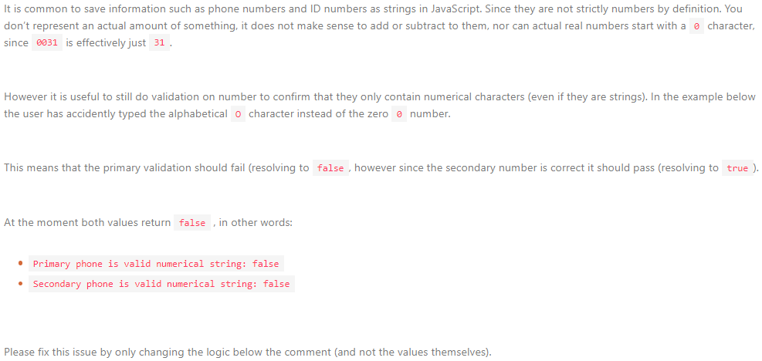

const primaryPhone = 'O748105141'

const secondaryPhone = '0219131568'

// Only change below this line

const primaryValid = typeof number == primaryPhone

const secondaryValid = typeof number == secondaryPhone

console.log('Primary phone is valid numerical string:', primaryValid)

console.log('Secondary phone is valid numerical string:', secondaryValid )

**Challenge i**

const rent = 400;

const tax = '8%';

const food = 51.7501;

const salary = 800;

const transport = 10.2;

const hourOfDay = 00;

const minuteOfDay = 00;

// Only change below this line

if hourOfDay && (minuteOfDay !== null) && (hourOfDay == '00') && (minuteOfDay == '00') {

const taxAsDecimal = tax / '100'

const startingAfterTax = salary * '1' - taxAsDecimal

const balace = starting - transport - food - rent

}

console.log(balance.toFixed(3))